

**Report On “AgroDoctor”**

**Submitted To:**

ASIF KHAN SHAKIR

Lecturer (Senior Scale)

Department of Software Engineering

Daffodil International University

**Submitted By:**

Ahsan Habib (193-35-2920) &

Al Imran Akash (192-35-2855)

Section: A2

Course Code: SE331

Course Title: Software Engineering Design Capstone Project.

**Project Name: “AgroDoctor”**

**Project Proposal**

* 1. **Background Study**

**1.1.1 Overview of farmers in Bangladesh**

According to the National Agricultural Census report has said Bangladesh is currently home to 16.5 million farmer families. That’s means 75% people are farmer in bd.

**1.1.2 Challenges faced by Farmer**

* Cope with climate change, soil erosion and biodiversity loss.
* Satisfy consumers' changing tastes and expectations.
* Meet rising demand for more food of higher quality.
* Invest in farm productivity.
* Adopt and learn new technologies.
* Stay resilient against global economic factors.

**1.1.3 Impact of these challenges**

Attack tropical cyclones

* Economic impact.
* Rising temperatures etc

**1.1.4 Solution for these challenges**

Use renewable energy.

* Industrial Solutions.
* Provides the proper knowledge of the problem
* Gives proper information of cultural differences.
  1. **Motivation**

The goal of this project is to develop a sustainable and scalable platform for **farmer and Agronomist** by providing access to essential tools. So that both parties can benefit.

* 1. **Objective**

**1.3.1 Objective for AgroDoctor Authority**

* Ask for agriculture related problem and get a solution.
* Communicate with Agronomist.
* Develop a system where they will verify their identity with NID card.
* Maintain quality.

**1.3.2 Objective for farmer**

* To develop a system where farmer will easily find a solution of any Agriculture related problem.
* Post and interact in their recent solution experience.
* Give review to AgroDoctor .
* Develop a system where they will verify their identity with NID card.
  1. **Outcome**

**1.4.1 Outcome for Farmer**

This mobile application will be a complete helper of farmers who want to grow their production more and gain more profit per year. Previously they can get suggestion from the doctor by using the application and share their post among all the doctor’s. So they will easily get benefited without going anywhere from home

**1.4.2 Outcome for Agronomist**

* They will get the target platform and target customers.
  1. **Assumptions and Constraints**
* Main constraints about the application that farmers can also make chat and video call through this app and also text chat based on their needs. Also they need to see some tutorial video about how to use this app and post their query.

**1.6 Dependencies and Risks**

* The risk about to develop this app is related to the information security that will be provided by the Agronomist and others user. So its also will be a matter of concern and security of this app to ensure user integrity and benefit.
  1. **Timeline**

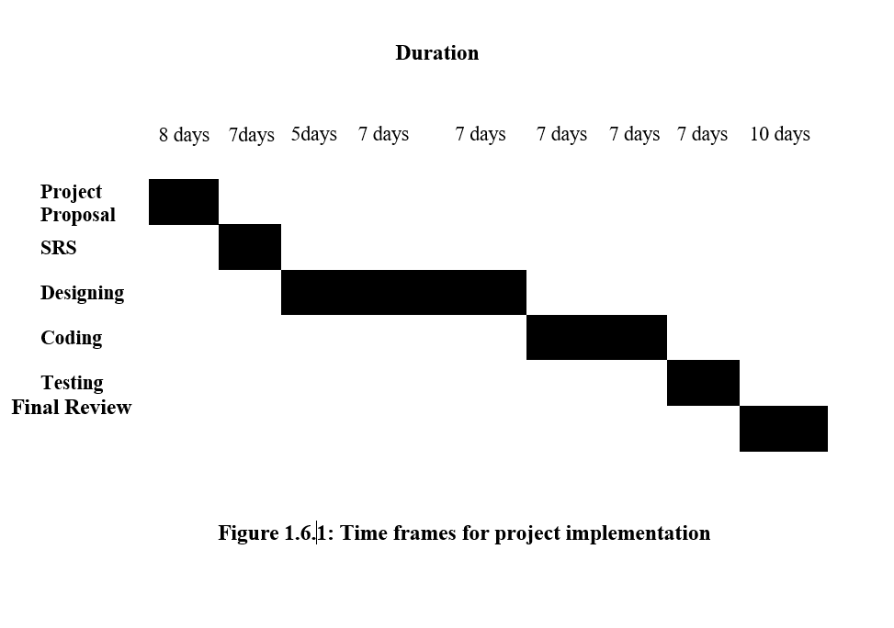

|  |  |  |
| --- | --- | --- |
| Project Proposal | Akash And Habib | 8days |
| Software Requirement Specification | Akash And Habib | 7 days |
| Software Design | Akash And Habib | 19 days |
| Coding | Akash And Habib | 14 days |
| Software Testing | Akash And Habib | 7 days |
| Final review | Akash And Habib | 10 days |

**Table 1.6.2 Work Distribution**

**Software Requirement Specification**

**2.1 Introduction**

The introduction of the Software Requirements Specification (SRS) provides an overview of the entire SRS with purpose, scope, definitions, acronyms, abbreviations, references and overview of the SRS. We can gather information and feedback and we should have proper knowledge for this system. The detailed requirement of the agriculture management system is provided document.

**2.1.1 Purpose**

As they will be benefitted who have use this system. To meet the needs of all. Let them understand their actions better and can solve. As farmers can create their profile and ask different type of question with information, doctor can see farmers post and help they by providing proper solution and Doctor can also post about different types of disease and proper medicine for them.

**2.1.2 Scope**

This web application will be a complete helper of farmers who want to grow their production more and gain more profit per year. Previously they can get suggestion from the doctor by using the application and share their post among all the doctor’s. So, they will easily get benefited without going anywhere from home.

**2.2 Overview**

This will be a web application named “AgroDoctor” where different types of users will be present and they can do different types of operation through this mobile app. Such as there will be Farmer user who can register or can ask a question as guest about their corps and other lands details through the app. They can provide images and other necessary information to ask their question. There will be another main user called Doctor where they can see the questions that public asks and answer through the mobile application. Another user will be the admin who will maintain all the operation using the application. Main constraints about the application that farmers can also make chat and video call through this app and also text chat based on their needs. Also, they need to see some tutorial video about how to use this app and post their query.

**2.3 User Classes and Characteristics**

There are three types of users in this system. First user is Admin and last two users are farmer and Agronomist. Admin setup this system ad adds any member and also can post in a page. He maintains all the operation and invite Doctors and farmers. Farmer can see all the post and get information by the doctor. Doctor can see the questions that farmer asks and answer through the app.

**Admin:** Admin control this mobile application. and through doctor and farmers information in this app. He maintains the application properly.

**Farmer:** Farmer user who can register or can ask a question as guest about their corps and other lands details through the app. They can create their profile and ask different type of question with information.

They can get suggestion from the doctor by using the application and share their post among all the doctor’s. So, they will easily get benefited without going anywhere from home.

**Agronomist**: He is the main user. Doctor can see farmers post and help they by providing proper solution. Doctor can also post about different types of disease and proper medicine for them.

**2.4 Requirement specification**

The complete requirement specification based on the elicitation process is described in this section.

**2.4.1 Functional requirement**

The Functional Requirements Specification is designed to be read by a general audience. Readers should understand the system, but no particular technical knowledge should be

|  |  |
| --- | --- |
| **FR-01** | Member Information |

|  |  |
| --- | --- |
| **Description** | Admin can add a new admin. And through doctor and farmers information in this app. He maintains the application properly. |
| **Stakeholders** | Admin |

|  |  |
| --- | --- |
| **FR-02** | **Update Farmer Details** |
| **Description** | Admin setup this system and add any farmer. He maintains all the operation and invite farmers. Farmer can see all the post and get information. |
| **Stakeholders** | Admin, Farmer |

|  |  |
| --- | --- |
| **FR-03** | **Update Agronomist Details** |
| **Description** | Doctor can see the questions that farmer asks and answer through the app. Admin share doctor’s post and medicine name. Doctor can also post about different types of disease and proper medicine for them. |
| **Stakeholders** | Admin, Doctor |

|  |  |
| --- | --- |
| **FR-04** | **Unregistered farmer and doctor** |
| **Description** | Admin can delete the details of the farmers and doctors and it also deletes these details in database. |

|  |  |
| --- | --- |
| **Stakeholders** | Admin |
| **FR-05** | **Search for product** |
| **Description** | Admin can search the details of the students and the system displays the specific member |
| **Stakeholders** | Admin |

|  |  |
| --- | --- |
| **FR-06** | **View farmer and agronomist Details** |
| **Description** | Admin, farmer as well as doctor can view the entire details of the doctor and farmer who are registered |
| **Stakeholders** | Admin, Farmer, Agronomist |

**2.5 Performance Requirements**

A requirement that specifies a performance characteristic that a system or system or system component must possess; for example, speed, accuracy, frequency.

**2.5.1 Speed and latency Requirements**

The system is required a fair amount of speed especially while browsing game lists to take bet on a posted game.

|  |  |
| --- | --- |
| **PR-01** | The Landing page will response within a second |
| **Description** | While the user’s browsing the system the landing page will show within a second. It also depends on user’s internet connection |
| **Stakeholders** | Admin, Farmer, Agronomist |

**2.5.2 Precision and Accuracy Requirements**

There are no specific precision and accuracy requirements.

**2.5.3 Capacity Requirements**

The system is able to manage all the information of passed out farmers and doctors.

|  |  |
| --- | --- |
| **PR-01** | Initially the system will store 40,000 doctors and farmers information |
| **Description** | The information of farmers and doctors will be stored in database |
| **Stakeholders** | Admin, Farmer, Agronomist |

**2.5.4 Dependability Requirements**

The flexibility of current frameworks encourages system architects to enable reconfiguration mechanisms that refocus the available, safe resources to support the most critical services rather than over-provisioning to build failure-proof system. Therefore, these requirements are essentials.

**2.5.5 Reliability and Availability**

In order to support global and smooth operations the system must be available around the clock. On the other hand, most services in this system are not mission-critical. Even better the game posting can handle times of downtime as the users usually interact with high availability from third party website. This system will be able to catch up with their data once it's up and running again.

|  |  |
| --- | --- |
| **DR-01** | The system must be available 24x7 |
| **Description** | * The system must be available 24 hours in a day * The system must be updated regularly. * The system must publish the information, posting crops diseases, medicine details and update these regularly |
| **Stakeholders** | Admin, Farmer, Agronomist |

**2.5.6 Robustness and Fault Torrance Requirements**

The system will almost ensure 0% crush in any single minor error and don’t give any wrong calculation

|  |  |
| --- | --- |
| **DR-02** | The system handles over access and system errors |
| **Description** | Sometimes multiple users can over access to this system. The system can handle multiple user access |
| **Stakeholders** | N/A |

**2.5.7 Safety Critical Requirements**

There are no specific safety critical requirements

**3.0 Use Case**

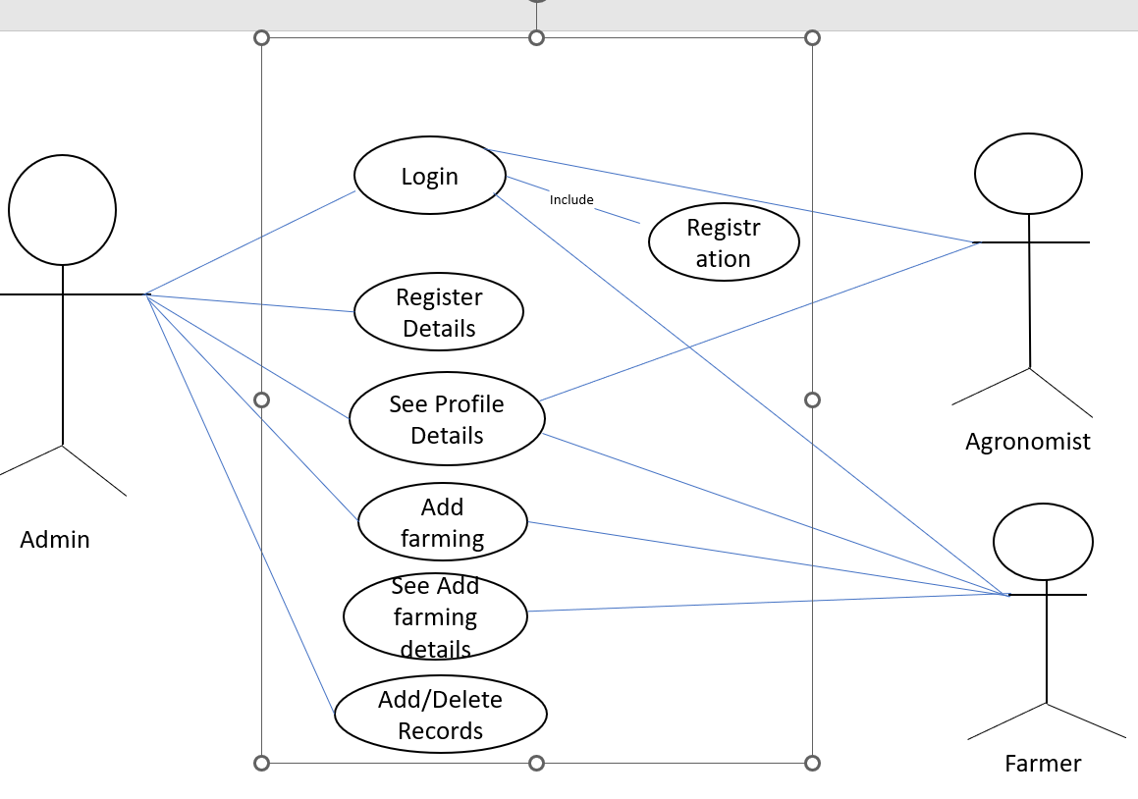

**4.0 Use Case Description**

**4.1 Login**

|  |  |
| --- | --- |
| **Usecase Name** | **Login** |
| Actor | Farmer/Agronomist |
| Flow of events | 1. Click login 2. Enter username and password 3. Click submit button |
| Alternative | 1. If login fails click on forgot password. 2. Enter recovery mail and new password. 3. Click submit. |

**4.2 Registration**

|  |  |  |
| --- | --- | --- |
| **Usecase Name** |  | **Register Details** |
| Actor |  | Admin |
| Precondition |  | Registration |
| Flow of events |  | **1.** Click “Add registration” option  2**.** Give all necessary information  3**.** Click “Save” |

**4.3 See Profile Details**

|  |  |
| --- | --- |
| **Usecase Name** | **See Profile Details** |
| Actor | Admin, Agronomist, Farmer |
| Precondition | Login |
| Flow of events | **1.** Click “**See Profile details**” option  **2.** See the profile details |

**4.4 Add Farming**

|  |  |
| --- | --- |
| **Usecase Name** | **Add Farming** |
| Actor | Farmer |
| Precondition | Login |
| Flow of events | **1.** Click “**Add Farming” option**  **2.** add farming type |

**4.5 See Farming Details**

|  |  |
| --- | --- |
| **Usecase Name** | **See Farming Details** |
| Actor | Farmer |
| Precondition | Login |
| Flow of events | **1.** Click “**Add Farming” option**  **2. See the**  farming type Details |

**4.6 Add or Delete Record**

|  |  |
| --- | --- |
| **Usecase Name** | **Add or Delete Record** |
| Actor | Admin |
| Precondition | Login |
| Flow of events | 1. Add Or Delete Farmer Record |

**5.0 Erd Diagram**



**6.0 Sequence Diagram**

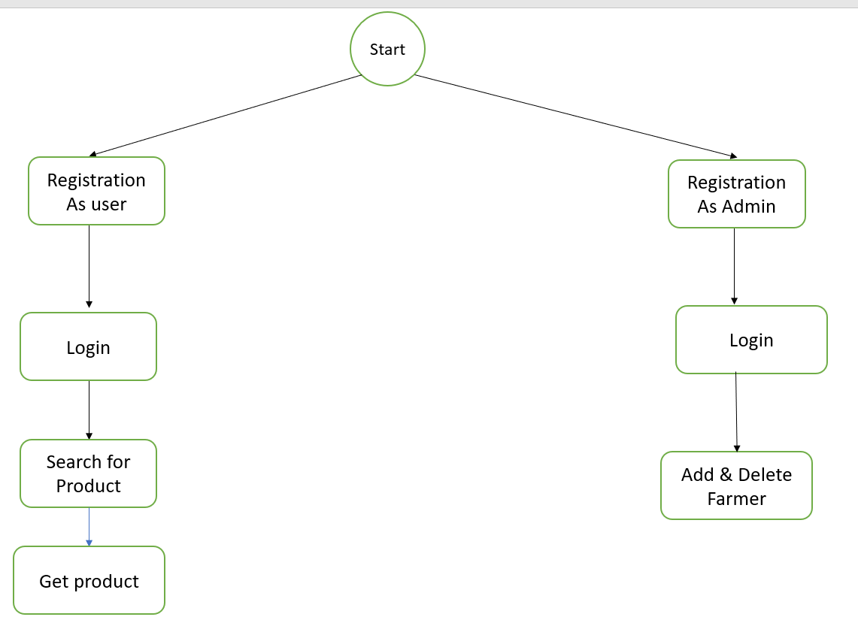

**6.1 Registration**



**6.2 Profile manages**



**6.3 Delete User**



**7.0 Final Output**

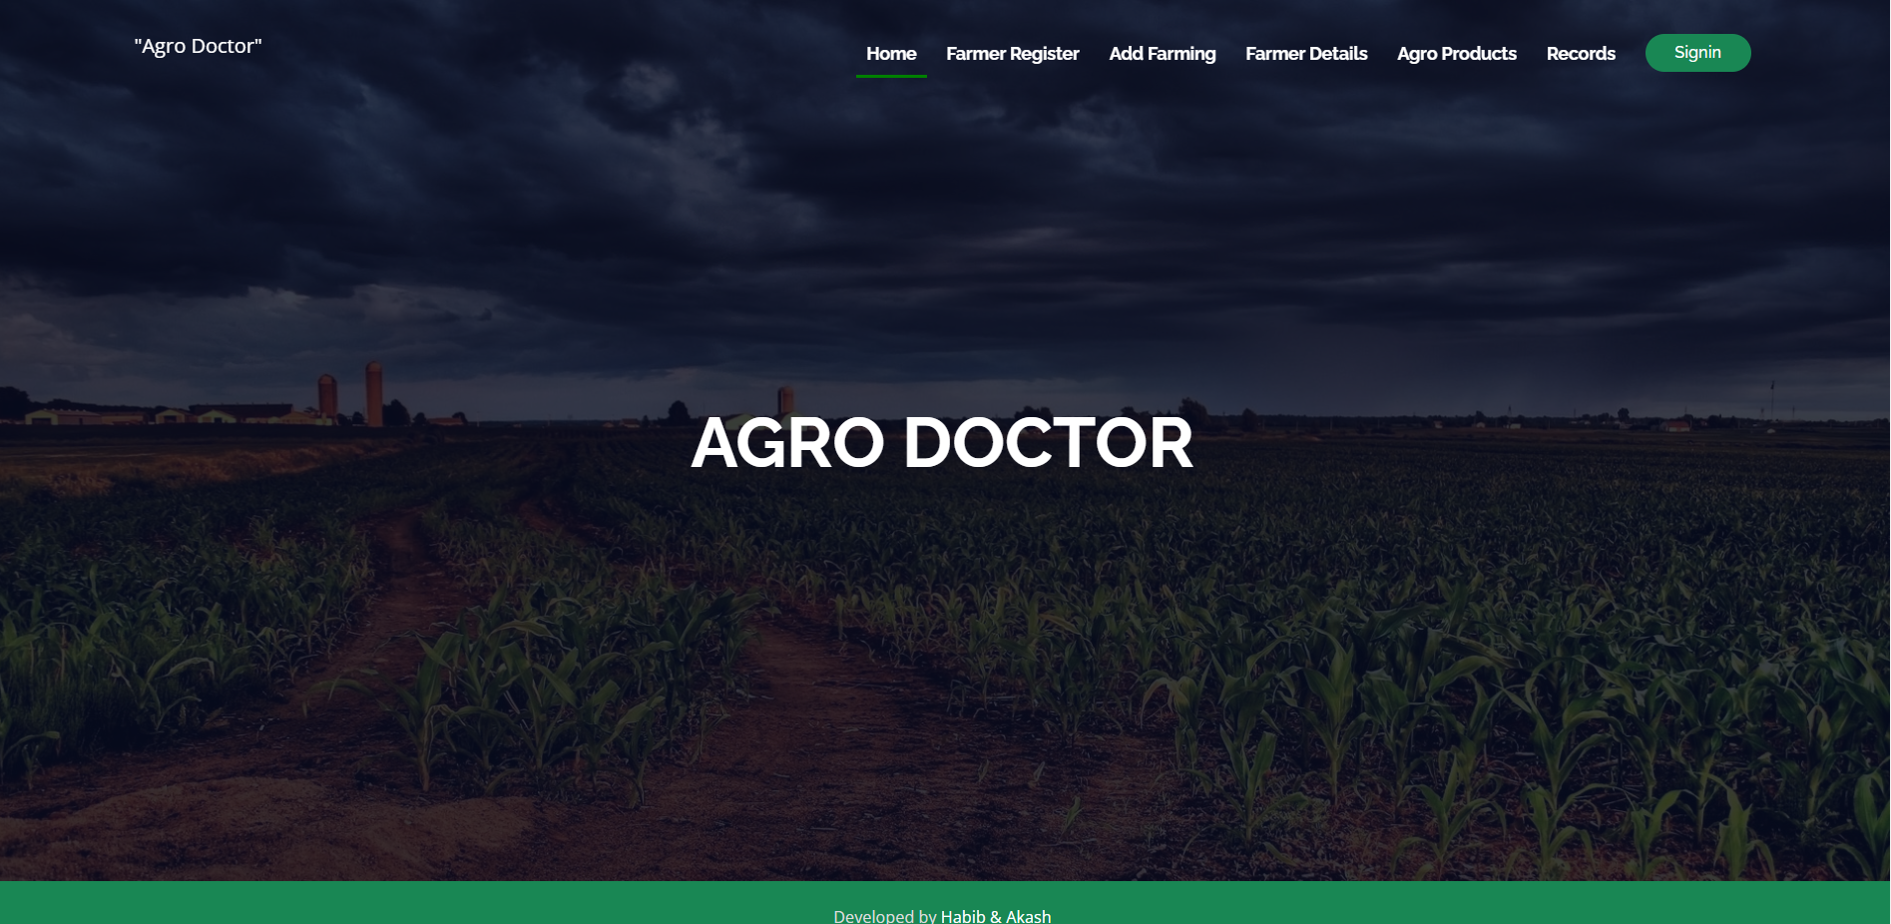

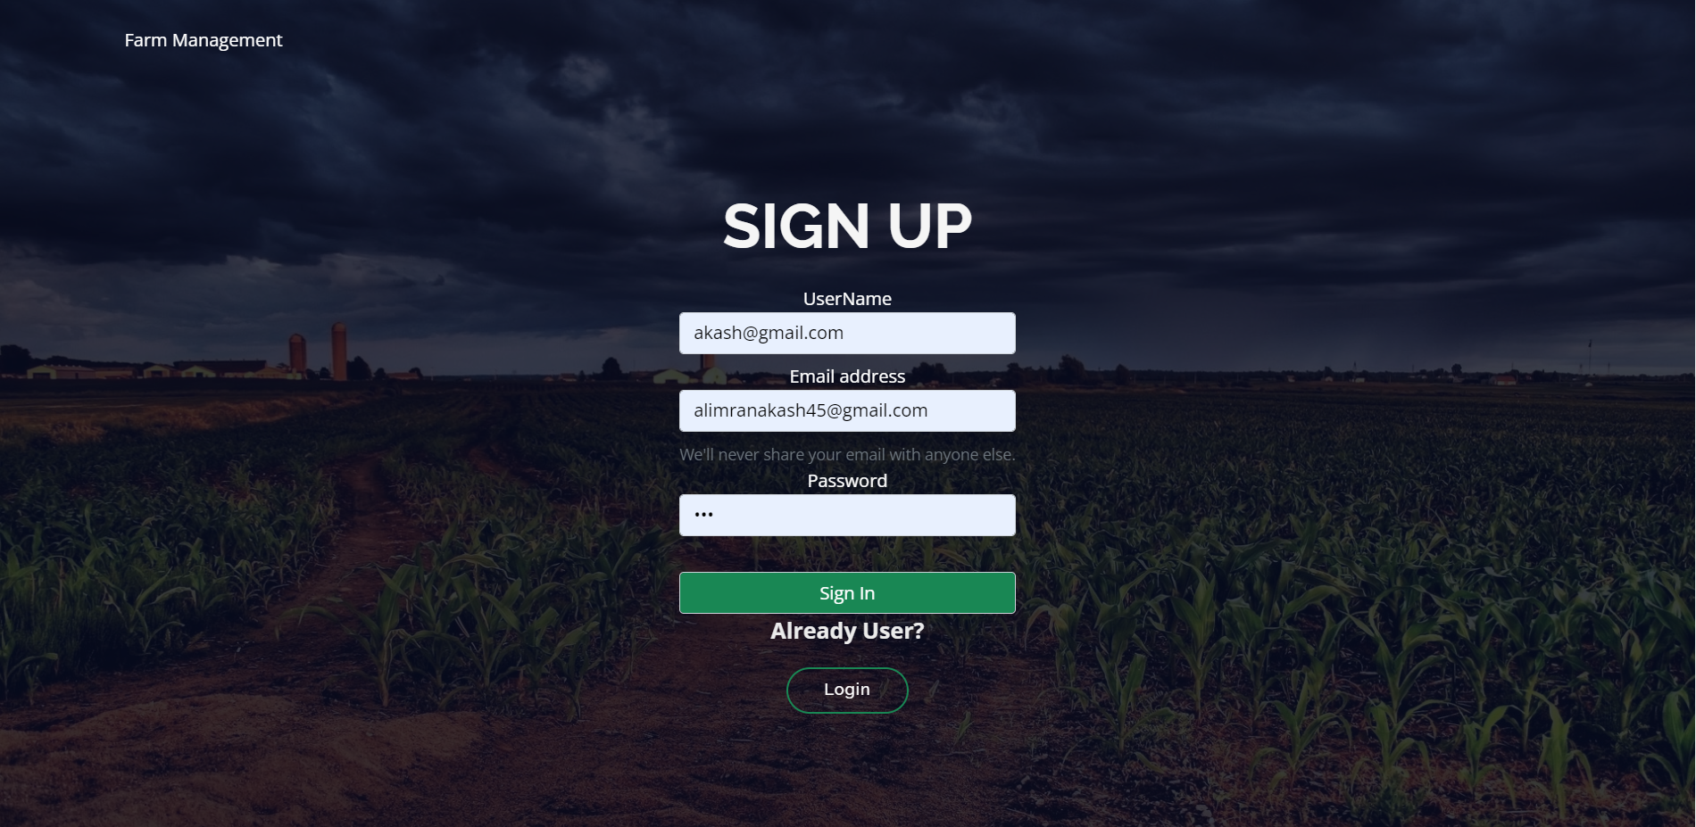

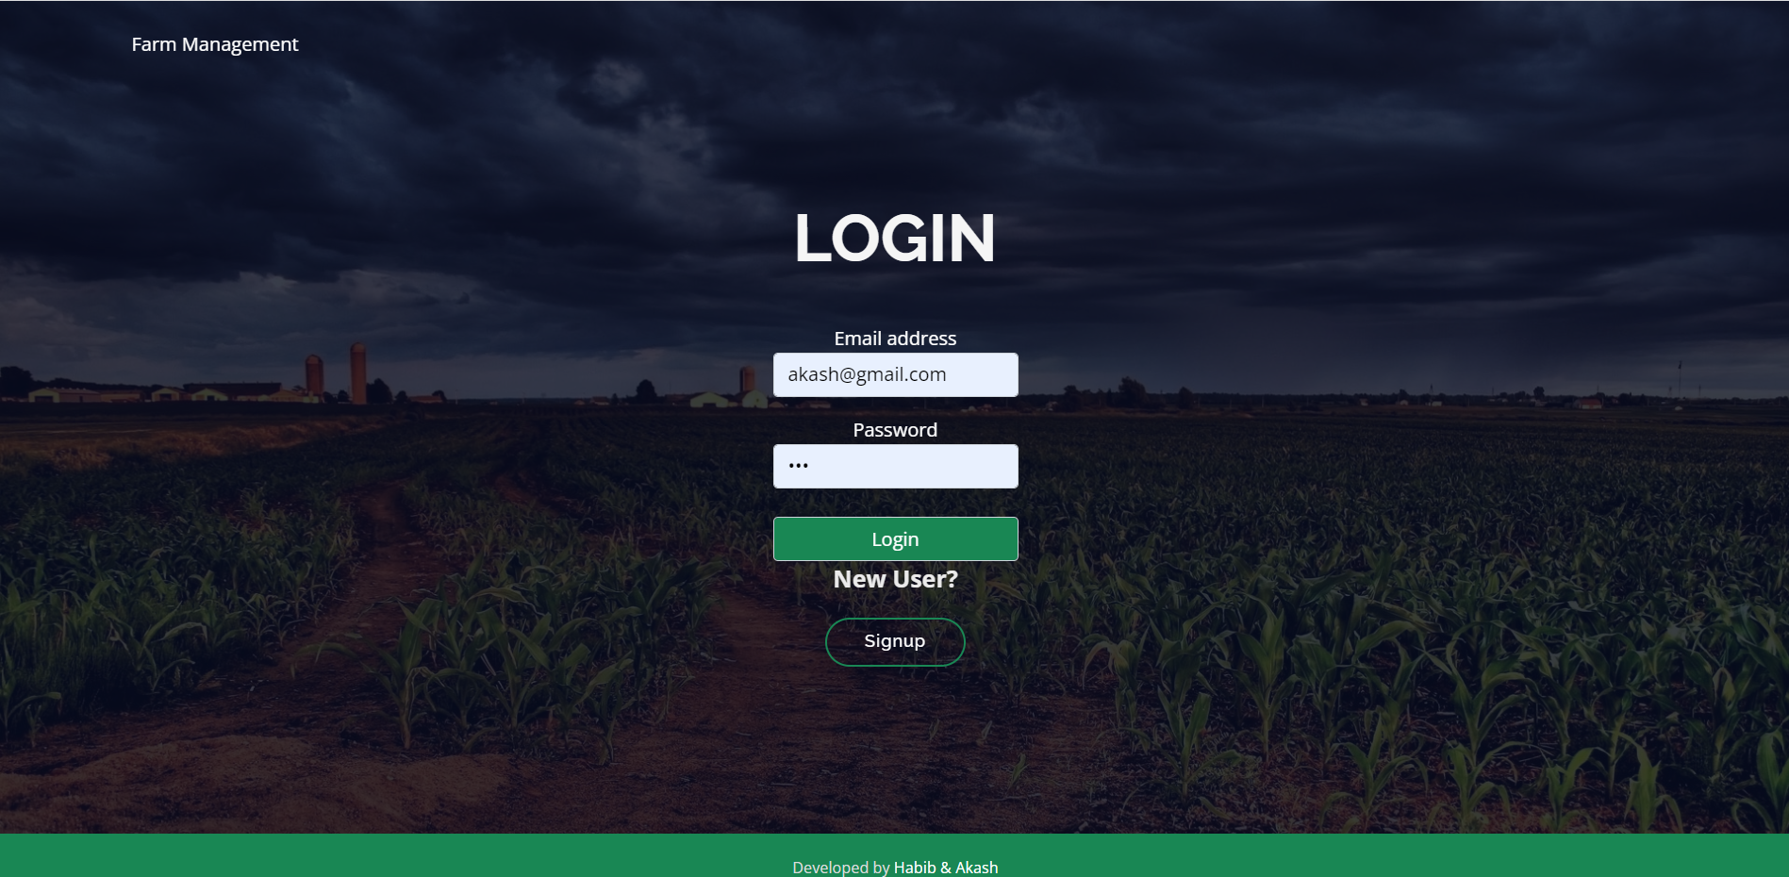

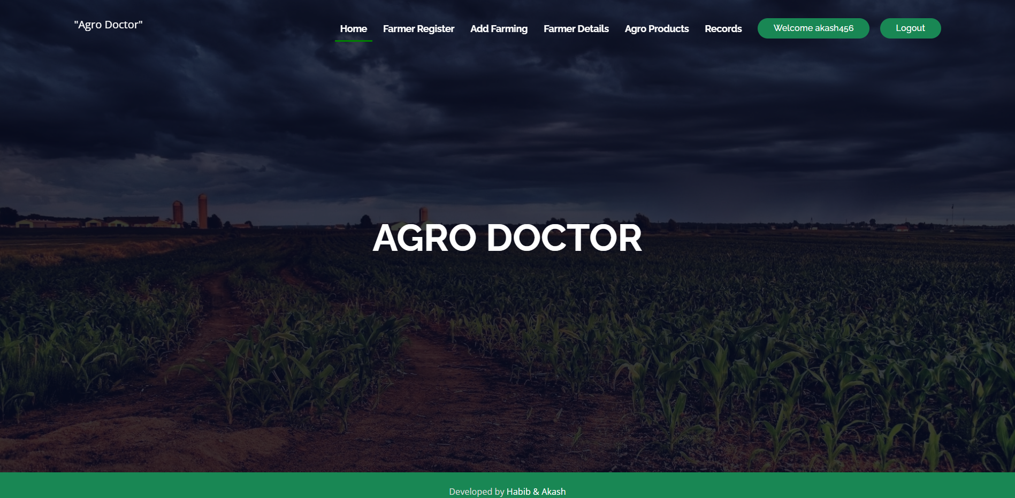

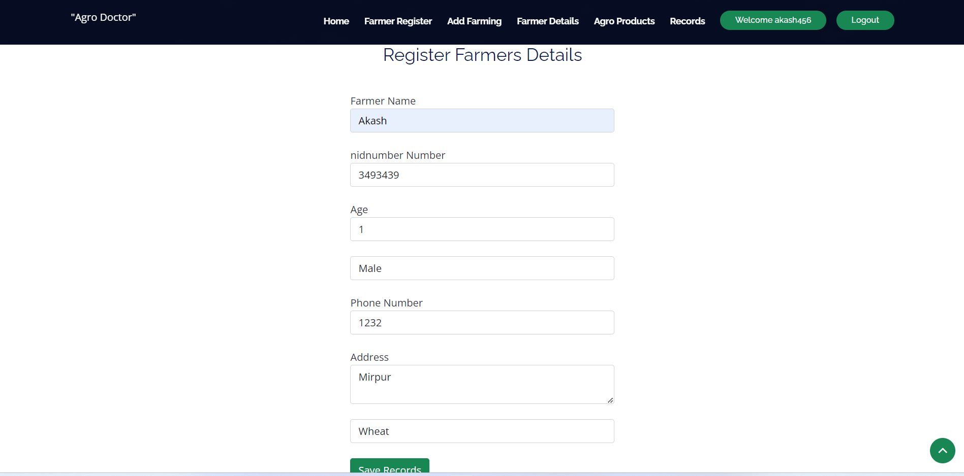

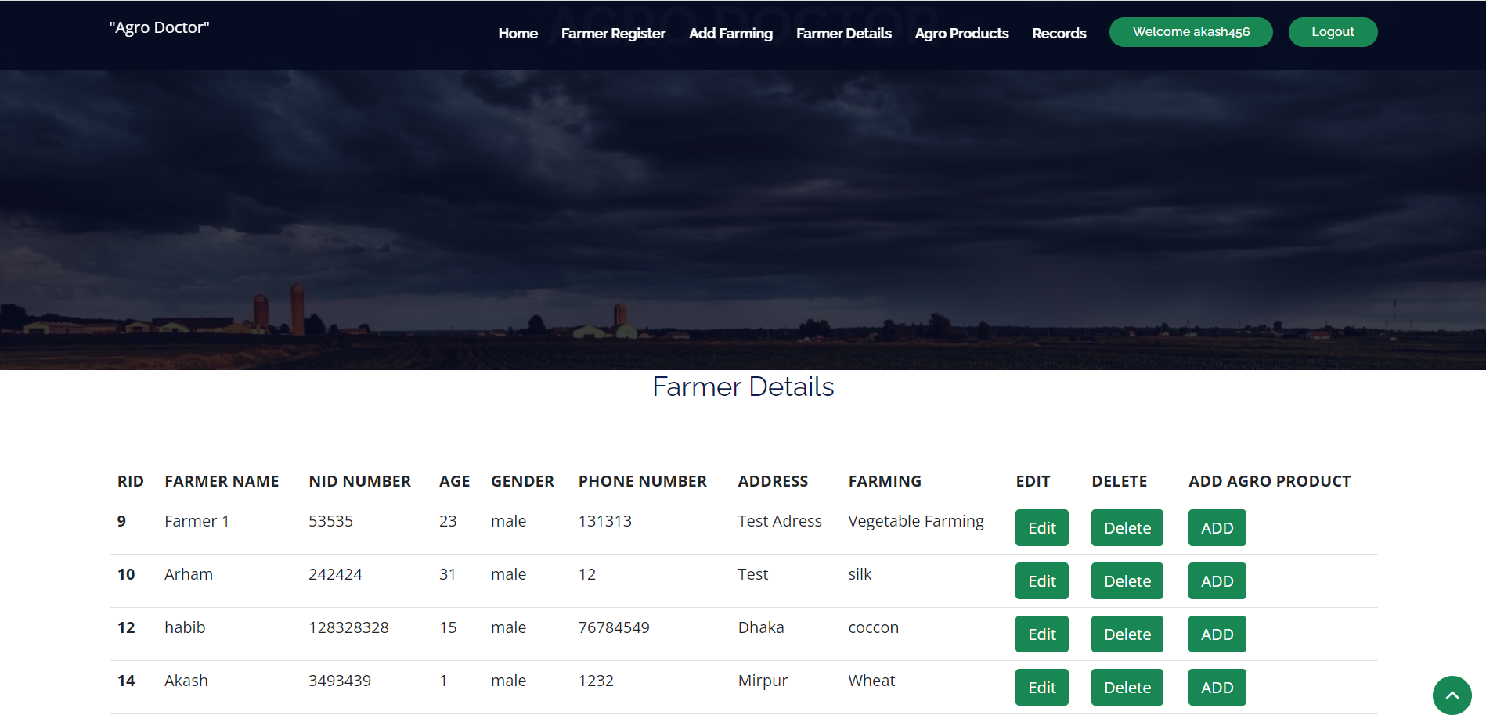

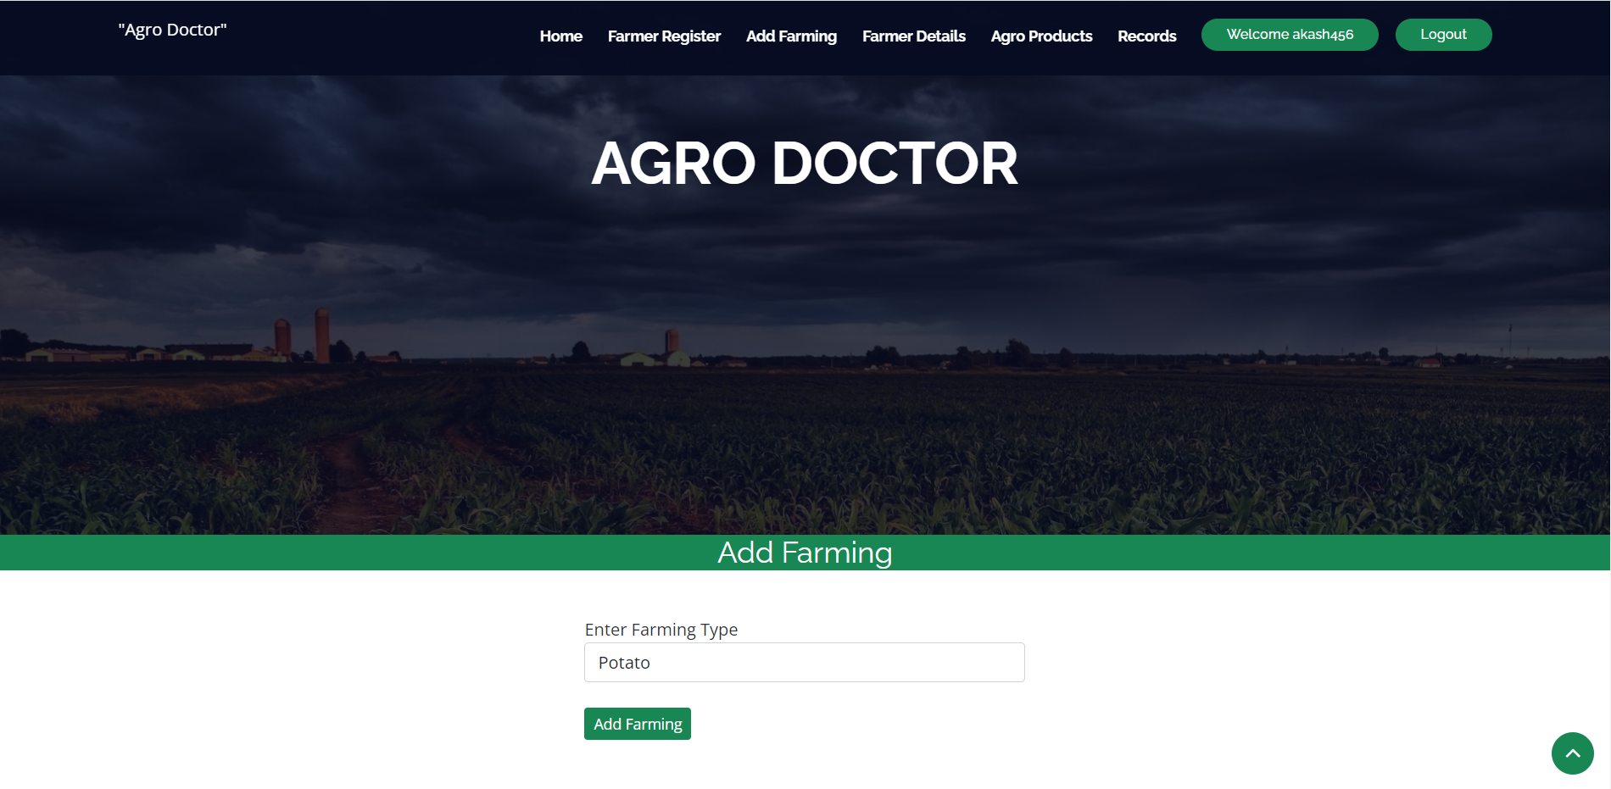

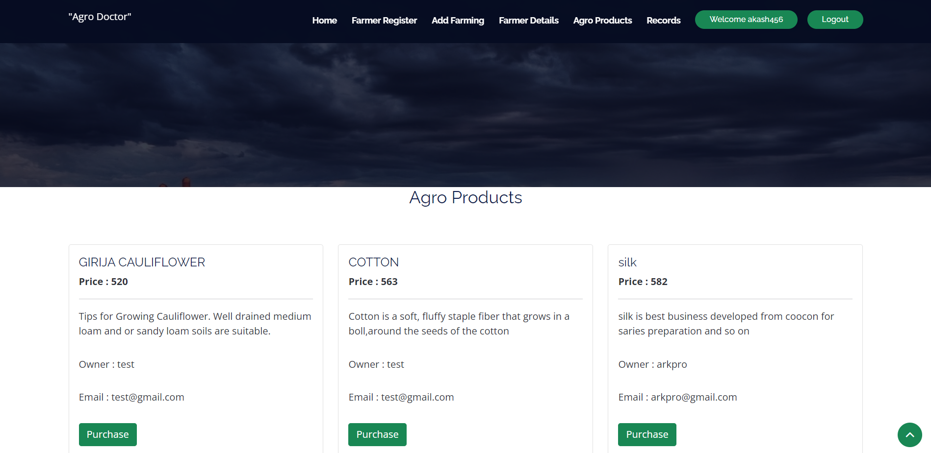

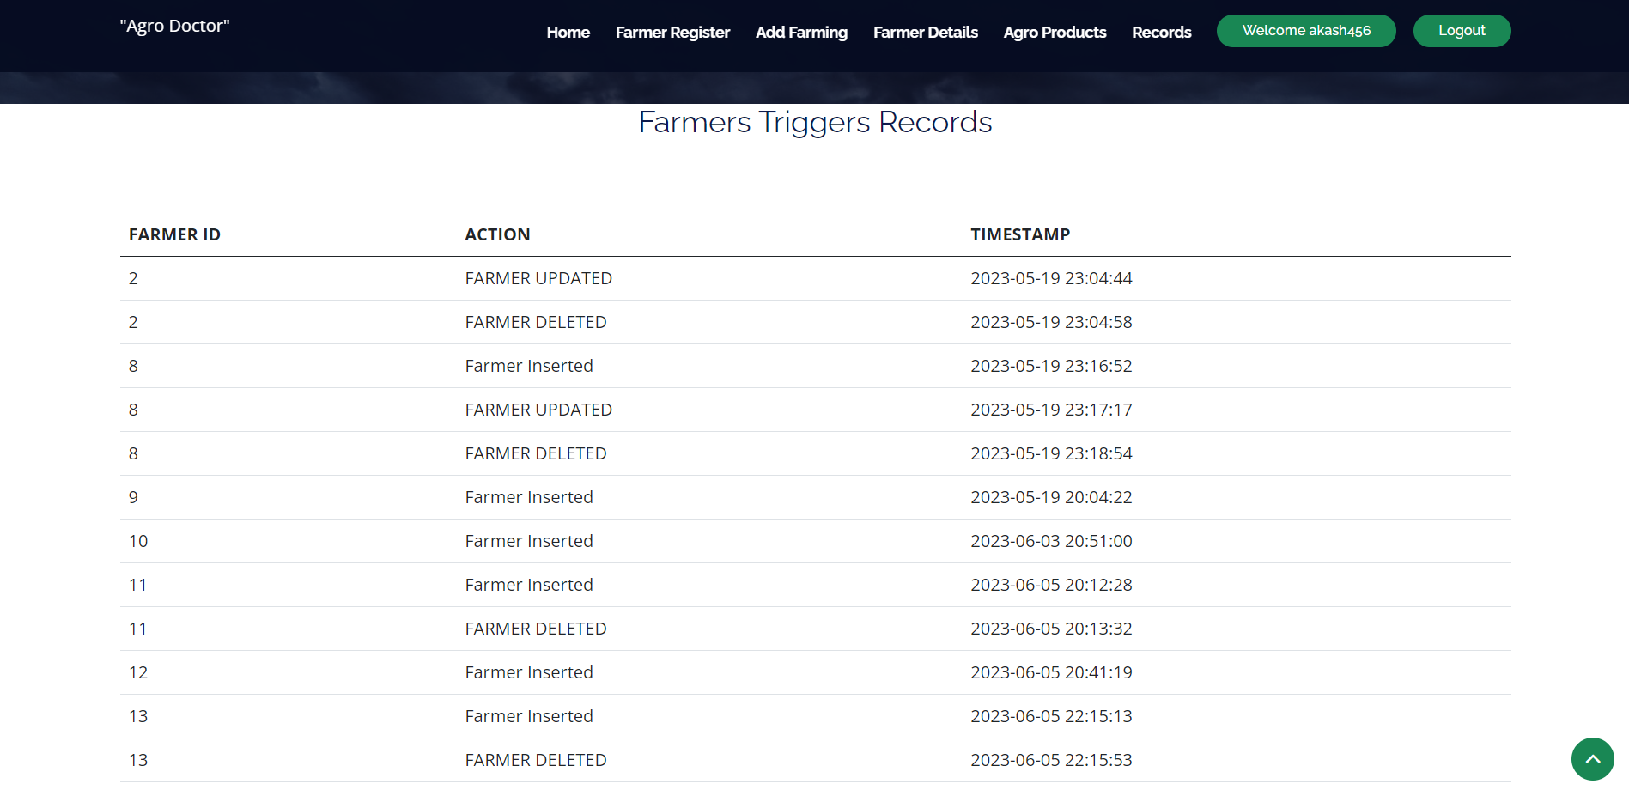

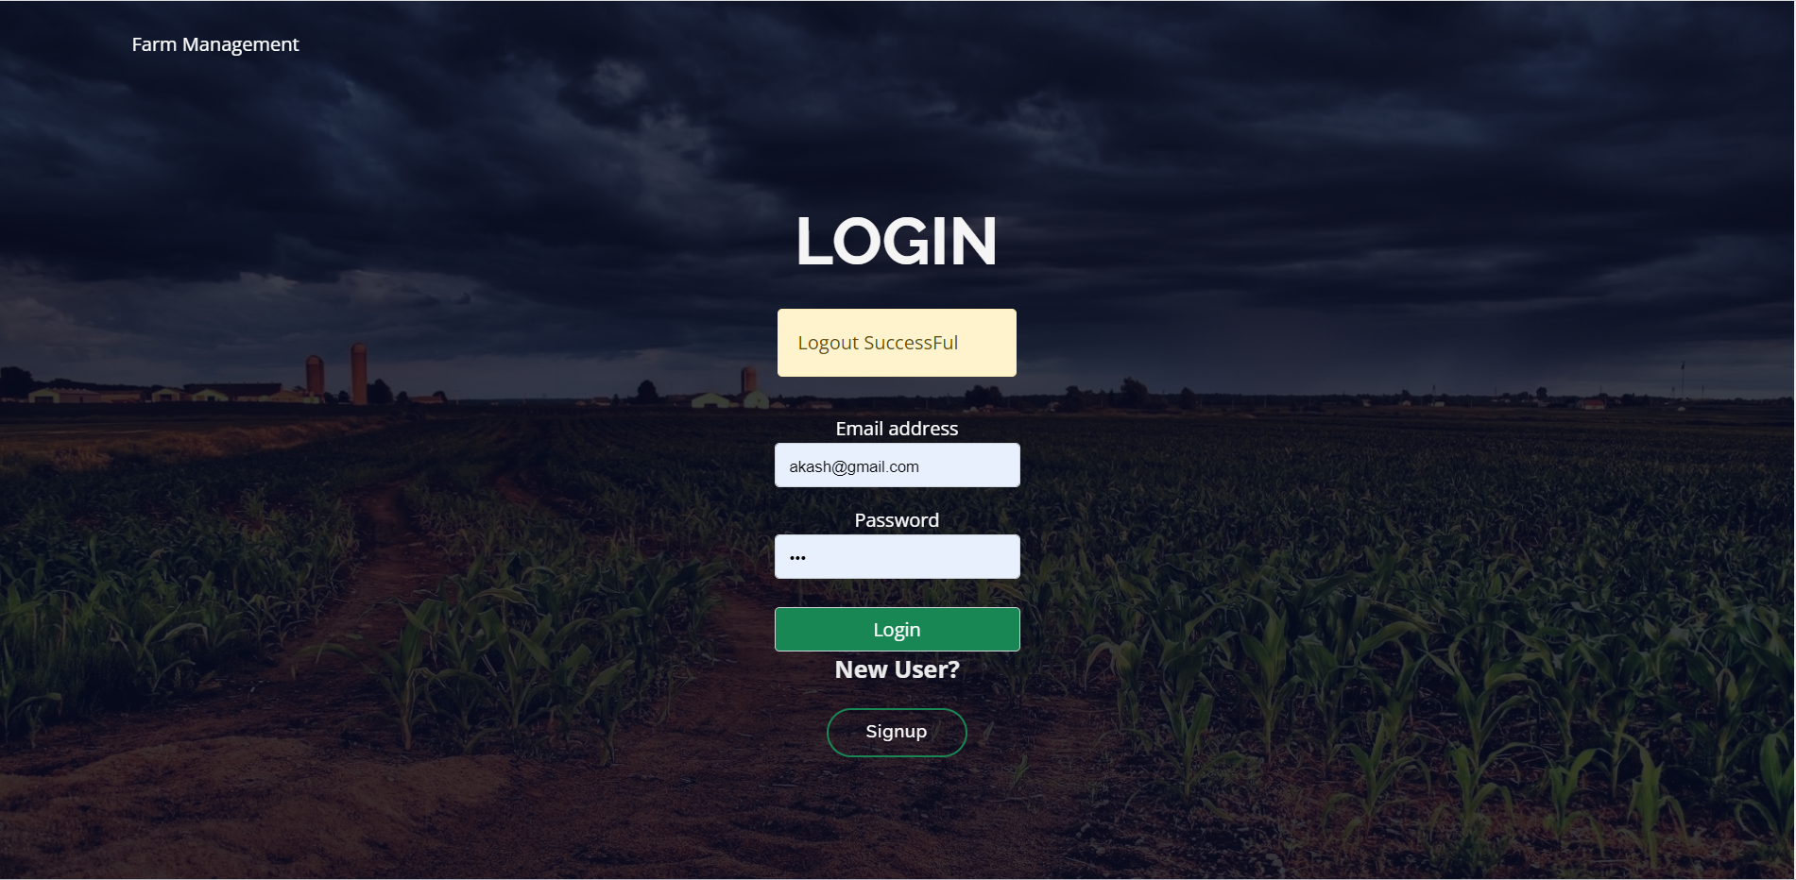

**8.0 Database**

